Butler County Board of Developmental Disabilities
PROVIDER MEETING AGENDA
January 18, 2023
10:00am-11:00am
Zoom Link:
https://us02web.zoom.us/j/81632305890?pwd=bWs3ZGNjL0dtdFdmOGowUWRUd0lEZz09

PNM Overview- Rebecca Gaspard and Jared Mutchler, DODD
See recording for minutes.
Jared Mutchler- jared.mutchler@dodd.ohio.gov
Rebecca Gaspard- Rebecca.gaspard@dodd.ohio.gov

Community Connections Newsletter- Jenny Mann, Community Connections Coordinator, BCDD-
Please sign up for our Community Connections Newsletter – Link below
https://lp.constantcontactpages.com/su/oKwhfb8
Connie Mehlman - cjmehlman@butlerdd.org
Jenny Mann - Jamann@butlerdd.org
Butler County Board of DD website:
Employee Spotlight of the Month and Monthly DSP Appreciation – Go online and make your nominations.

Quality Assurance Department Updates- Kara Frederick, Quality Assurance Director, BCDD
Covid Test are available at Butler County Board of DD Janet Clemmons Center
Welcome Cathy Borders, Quality Assurance Provider Relations Coordinator

Provider Updates - Amy Winkler, Quality Assurance Provider Relations Coordinator, BCDD

- Provider Portal Redesign Launched
  - New features including the ability to track application history and request to add additional agency user profiles
  - All providers must create a new password to log into the redesigned portal initially

- Changes Coming to DSP Courses in DODD MyLearning January 1
- The MyLearning homepage will have four options (rather than six) for Courses for Direct Support Professionals. Separate categories for DSPs at licensed facilities are no longer needed because the DSP training requirements in the licensed residential facilities rule are now in line with the DSP training requirements for waiver settings.
- Annual training for DSPs and independent providers will contain a total of eight hours training, so learners can complete all annual training using MyLearning if they wish.

- Extension Granted for MUI Annual Reviews and Stakeholders
At the end of August 2022, we transitioned our Major Unusual Incident data to a new application called the Ohio Incident Tracking and Monitoring System (OITMS). One of the exciting changes about the system is that reports will be available in the application as opposed to being accessed through the data warehouse. While the data warehouse is still available for use, it does not include MUI data past August 31, 2022, when we launched the new system. Reports utilized by providers and county boards are not yet available in OITMS but will be soon. The MUI Registry Unit and IT partners are working diligently to resolve these issues and will let you know through Memo Monday when these reports will be available. Due to the lack of availability of reports, DODD is granting an extension to providers and county boards in order to complete their annual MUI reviews.
- Independent and agency providers will be required to complete the annual review by April 1, 2023, (previously January 31, 2023) and send to the county board by April 28, 2023 (instead of February 28, 2023).

- 1099 Forms for Calendar Year 2022
The OBM (Office of Budget and Management) Shares Services (SS) will be mailing tax forms by the end of January. They must have a valid mailing address to send documents to. Please verify your address with OBM Shared Services by using the Ohio Pays portal at https://ohiopays.ohio.gov/, by calling 1-877-644-6771, or by emailing at OBM.sharedservicies@obm.ohio.gov.
If a form 1099 is returned for any reason, your account will be made inactive in OAKS, which will prevent payment.
Independent providers who made more than $600 in 2022 and who are listed in the state accounting system [OAKS] under their Social Security Number will be issued an IRS Form 1099-NEC (Nonemployee Compensation) by the office of Ohio Shared Services (OSS).
﻿Agency providers may receive a 1099 depending on the type of contractor as listed in OAKS. A corporation (including a limited liability company (LLC) that is treated as a C or S corporation) generally does not receive a 1099 form.
Any inquiries regarding taxes should be directed to your accountant or to the Internal Revenue Service (IRS). Providers are self-employed and have sole responsibility for taxes. Taxes are not withheld by DODD, and DODD cannot assist with questions related to taxes.

- DSP Quarterly Retention Payments Announcement

The Ohio Department of Developmental Disabilities (DODD) is launching the county board-funded Direct Support Professional (DSP) retention payment initiative for independent providers and DSPs of agency waiver providers.

Progress this week
On Tuesday, December 13, the Ohio Legislature amended language to authorize the payments into House Bill 45. The bill passed the Ohio Senate and Ohio House on Wednesday, December, 14 and is now awaiting Governor Mike DeWine’s signature, which is expected by the end of the year. Today, following legislative approval, Governor DeWine issued an emergency rule. This progress allows DODD to launch the initiative and partner with county boards of developmental disabilities to issue payments in the coming months.
How the initiative works
In July, the federal Centers for Medicare and Medicaid Services (CMS) approved the initiative with an effective date of July 1. This allows for these payments to be retroactive to that date. Quarterly payments will be distributed to participating home and community-based waiver providers that opt-in. Participating agency providers must distribute the vast majority of the payment to eligible DSPs. Every quarter, participating agency providers are then required to report certain data elements and attest that the funds were used in accordance with all requirements. Independent providers are eligible for payments and will not need to opt-in or report to participate.
This investment aims to assist Ohio's developmental disabilities system in addressing the workforce crisis through retention incentives for DSPs. With a federal match, county boards will generate approximately $143 million annually for retention payments to the DSP workforce.

First payment structure
Because the initiative is retroactive to July, initial payments will cover three quarters of payments. This will allow DODD to expedite payments allowing funds to get out sooner and will put the initiative on schedule with rule requirements by April. DODD will stagger the three initial payments to providers, which will assist providers in tracking how funds are passed along to DSPs. The table below shows how the first payments will be issued:
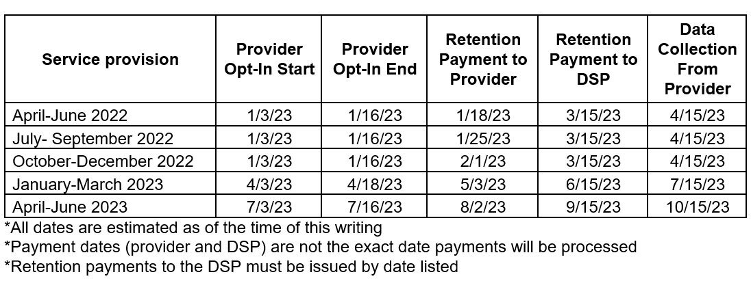

Starting Tuesday, January 3, waiver agency providers can enroll online at https://dodd.ohio.gov/providers/RetentionPayment. Registration will remain open for initial payments until January 16. Provider agencies and independent providers will receive the first payments in mid-January. Eligible DSPs employed by agency providers will receive payment from their employers by mid-March. Agency DSPs should talk with their employer to determine when they will receive their retention payments.
Please contact retentionpay@dodd.ohio.gov with any additional questions
A copy of the rule will be included with the meeting minutes.

- Public Health Emergency extended to April 2023
The U.S. Department of Health and Human Services (HHS) extended the federal Public Health Emergency (PHE) that has been in place since January 2020 and was set to expire January 11, 2023 for an additional 90 days.

This means that the PHE will expire in mid-April unless it is extended further. With the 6 month unwinding period beginning at that time, the following flexibilities will still be allowed through mid-October 2023 if there is an assessed need:
1. Parents of minors as paid providers (through agencies)
- Authorizing HPC and OSL on the same day

Additionally, President Biden has assured that there will be a 60-day notice before ending the Public Health Emergency. Learn more via the links below.

Trainings -

- Behavior Support Workshops
Join us to continue learning with questions/answers and scenarios to increase understanding of the behavior support rule updates.
Statewide Behavior Support Workshop - February 14, 2022 from 10 AM - 12 PM or call in at 614-721-2972 with ID# 279 921 037#

There will be a training that was presented at the OACB 2022 conference, "Myths & Misconceptions of the Rule, Blunt Suppression, Assessments, HRC Best Practices." This will be recorded and posted on the Behavioral Support webpage.

The dates and times for upcoming workshops will be posted under the Behavior Support Workshops section on the Behavioral Support webpage at https://dodd.ohio.gov/about-us/BehavioralSupportStrategies/Behavioral+Support+Workshops. No registration is necessary, just click the link to join.
Have questions? Reach out to behavior.support@dodd.ohio.gov.

- OSSAS Provider Training Series 2023
Join us for the OSSAS Provider Training Series - monthly virtual training opportunities. Training is held on the last Thursday of each month at 10 AM.
1/26/2023 10 AM – Start 2023 Off Right Learn about the Compliance Review Process, the Top Citations in 2022, and Maintaining Compliance
2/23/2023 10 AM – Personal Funds Rule
3/30/2023 10 AM – Your agency is certified, now what?
4/27/2023 10 AM – Background Checks and Training

Registration for sessions will be available in early January, please register here https://dodd.ohio.gov/compliance/ossas/ossas-provider-training-series
Contact: OSSAS Compliance Page or ossas@dodd.ohio.gov

- THS RSS webinar- Overcoming the DSP Shortage
You are invited to a Zoom webinar.
When: Feb 1, 2023 11:00 AM Eastern Time (US and Canada)

Register in advance for this webinar:
https://us02web.zoom.us/webinar/register/WN_LUIkzP7dRJmEH6tBLvHrsQ
After registering, you will receive a confirmation email containing information about joining the webinar.

- Medication Administration Cert. 1 renewal course
NEW! MEORC offers a Medication Administration Cert. 1 renewal course online with a virtual skills check. This 2-hour online course allows you to complete your continuing education requirements anytime! Then you schedule the virtual skills check with a MEORC nurse. This allows you to take the course when you need it and fast! No more waiting for a scheduled date for an in-person class.
We’ve already helped someone who expired the next day get their class completed and skills check done so that they were able to continue their important work!
Visit MEORC’s training center to learn more: https://meorc.talentlms.com/index.
The cost is $65

2023 Meetings:

March 15, May 17, July 19, September 20, November 15

10am-11am

